# Module 2

**Advanced CNNs in Keras**

**Transfer Learning on Pre-trained models and Image Processing**

## 📌 Transfer Learning in Keras

### 🔹 What Is Transfer Learning?

Transfer learning is a technique where a model developed for one task is reused as the starting point for a model on a second task. It’s especially powerful when you have limited training data for the new task.

* It works similarly to how humans apply known skills to new but related challenges.  
  *Example: Knowing how to play the piano helps you learn the organ more quickly.*
* In deep learning, it means **reusing a model pre-trained on a large dataset** (like ImageNet), and fine-tuning it on a smaller, task-specific dataset.

Involves taking a **pre-trained model**, such as VGG16 trained on ImageNet, and adapting it to a new dataset.

The idea is to reuse the **feature extraction layers** (like convolutional layers) while customizing the final layers for the new task.

Enables **faster convergence**, **higher accuracy**, and **training on smaller datasets**.

**Why use Transfer Learning?**

* **Reduced Training Time**:  
  The model already learned general visual features (edges, textures, shapes), so training starts from a strong baseline.
* **Improved Performance**:  
  Pre-trained models, optimized on large datasets, tend to generalize better on smaller ones.
* **Works Well with Small Datasets**:  
  Even with limited data, transfer learning achieves high accuracy because the model retains useful pre-learned features.

These advantages make it suitable for domains like **medical imaging** or **natural language processing**, where labeled data is scarce or expensive

### 🔹 Implementing Transfer Learning with Keras (Using VGG-16)

1. **Import Required Modules**

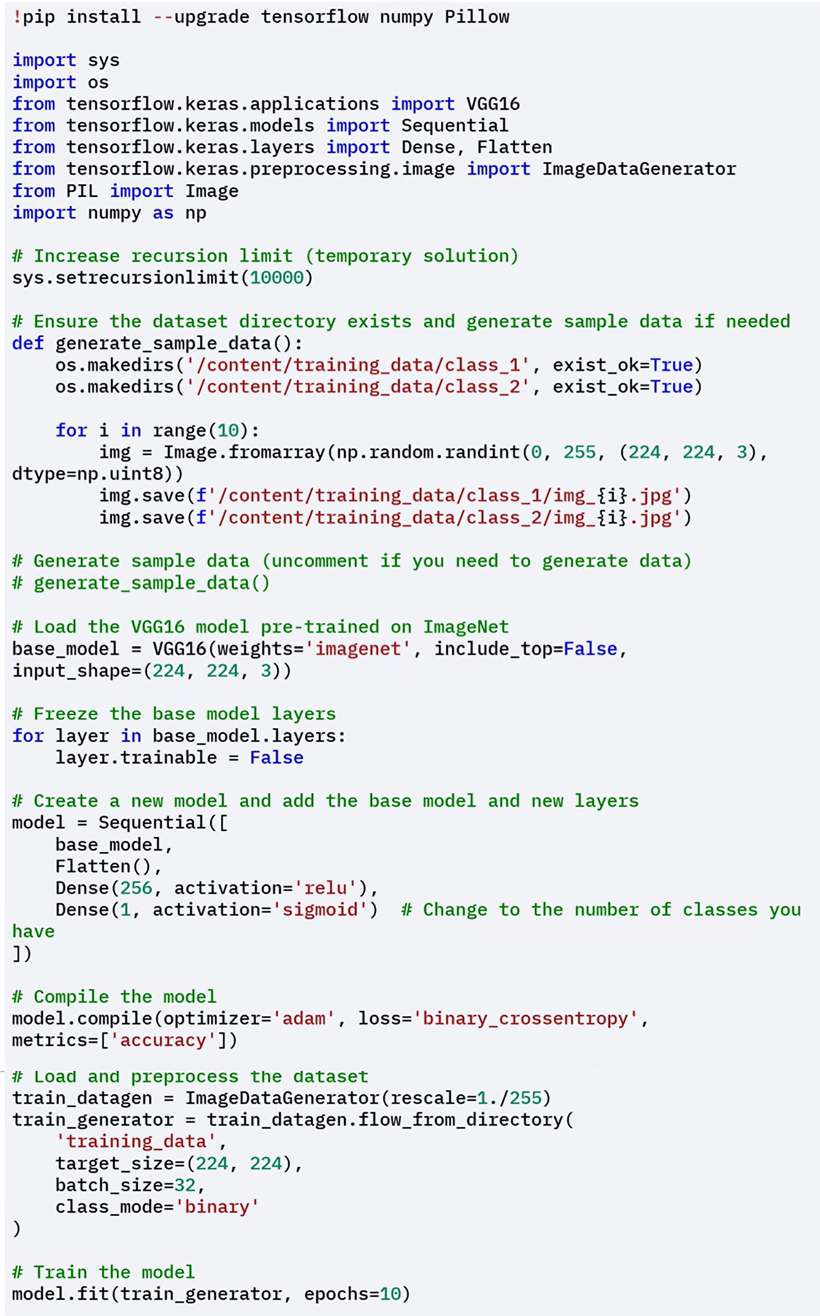

If you are working in environments with low default recursion limits (like Google Colab), increase the recursion depth to avoid runtime errors during model loading or training.

1. **(Optional) Generate Sample Training Data**



This was done to demonstrate transfer learning, create a simple image classification dataset:

* Two directories (*class_1/* and *class_2/*) are created under *training_data/*
* Randomly generated images are saved in each class directory to simulate a binary classification scenario

1. **Load the Pre-trained VGG-16 Model**



Import VGG16 from tensorflow.keras.applications:

* ***weights='imagenet'*** means it uses pre-trained weights. The model is pre-trained on ImageNet, which includes millions of images across thousands of categories.
* ***include_top=False*** argument excludes the original classifier layers, so you can add your own custom output layers.
* ***input_shape=(224, 224, 3)*** defines the shape of input images the model expects — 224×224 pixels and 3 color channels (RGB).

1. **Freeze the Pre-trained Base Layers**



To use the model as a **feature extractor**:

* You **iterate over all layers** in the base model. For each one, set layer.trainable = False.

This prevents the base model’s weights from being updated during training, preserving the general image features it learned from ImageNet.

1. **Create a New Model with Custom Classifier**



Using the Keras Sequential model, we stack:

* The **frozen base model** (VGG16 convolutional layers)
* **Flatten() layer** to transform the convolutional output into a 1D array
* **Dense(256, activation=’relu’) layer**: a fully connected layer to learn new patterns
* **Final Dense(1, activation=’sigmoid’) layer**:  
  This is the binary classification output (e.g., cat vs. dog)

The model is compiled with:

* **optimizer=’adam’**: A fast, adaptive optimizer
* **loss=’binary_crossentropy’**: Since this is a binary classification task
* **metrics=[‘accuracy’]**: To track classification performance during training

1. **Prepare Data**



You create an instance of ImageDataGenerator with rescale=1./255, which:

* Normalizes pixel values to a range between 0 and 1.

Using flow_from_directory():

* You specify the training data path (**'training_data'**)
* **target_size=(224, 224):** All input images are resized to match the model’s input shape
* **batch_size=32:** Images are processed in batches of 32
* **class_mode='binary':** Automatically assigns binary labels based on folder names

📂 for example, folder class_1/ will be one class, and class_2/ will be the other.

1. **Train the Model**

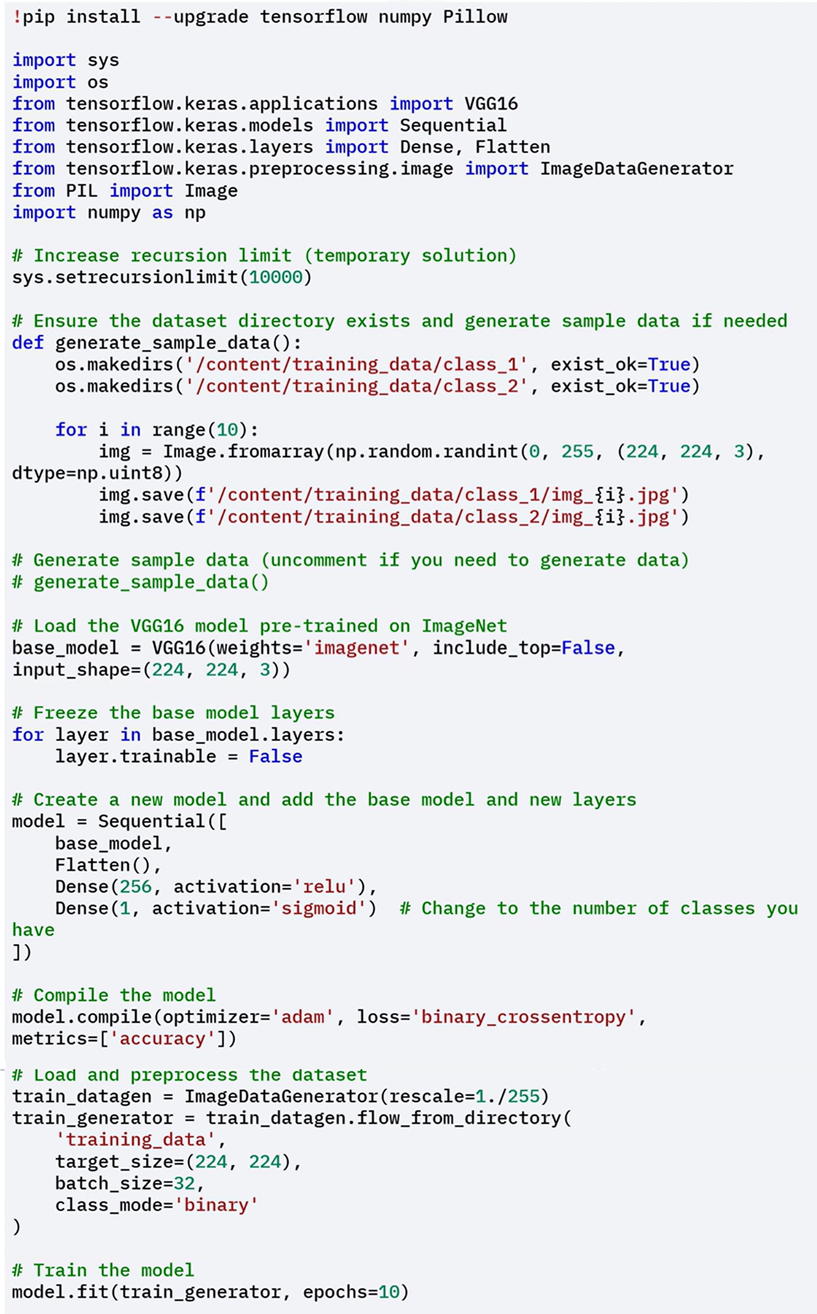

The model is trained using the **fit()** method, and uses **train_generator** as input. In this case the model is trained with *10 epochs* (it goes through the entire dataset 10 times)

### 🔹 Fine-Tuning the Pre-trained model layers

Instead of using the base model strictly as a feature extractor, you can **fine-tune some of its layers.**

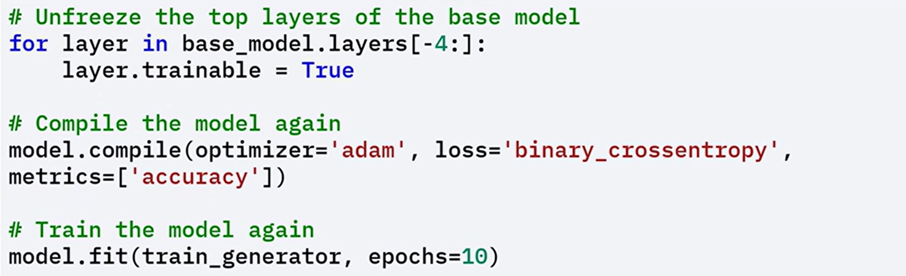

* Set **layer.trainable = True** for the **top 4 layers** of the base model
* Re-compile the model after unfreezing
* Train the model again with the same fit() call and dataset

This step lets the model adapt high-level pre-trained features to your specific task, improving performance even further.

### ✅ Takeaways

✅ Transfer learning **reduces training time**, boosts **performance**, and is especially helpful when working with **limited data**. It enables you to reuse knowledge from one task (e.g., ImageNet classification) for another.

✅ Pre-trained models like **VGG16** can be used as fixed feature extractors or fine-tuned for specific use cases.

✅ Keras makes it easy to import, freeze, and adapt pre-trained models to new tasks.

✅ Transfer learning is especially useful for domains where labeled data is scarce, such as:

* Medical imaging
* Natural language processing
* Object detection and classification

## 📌 Using Pre-Trained Models

Pre-trained models are deep convolutional networks trained on large-scale datasets such as **ImageNet**. These models capture low-level and high-level visual features like edges, textures, shapes, and object components through their convolutional layers.

Instead of training a new model from scratch, these pre-trained models can be reused for new tasks in two main ways:

1. **As fixed feature extractors**, without updating the weights.
2. **With fine-tuning**, to adjust some of the layers to fit the new task better.

Both approaches are widely used in real-world deep learning pipelines where labeled data is limited or compute resources are constrained.

### 🔹 Using Pre-trained Models as Feature Extractors

A pre-trained model can be used as a **static feature extractor**, where:

* The convolutional base processes new input images to generate **feature maps**.
* These feature maps are passed to new, task-specific **fully connected layers**.
* The **pre-trained weights are not updated** — the base is frozen.

This technique is effective when:

* The new dataset is small or similar in nature to the original dataset.
* The computational budget is limited.
* The goal is fast deployment with minimal training time.

⚡**Advantages of Fixed Feature Extraction:**

* **No additional training required**  
  The convolutional base processes new data without weight updates.
* **Efficient use of learned representations**  
  The pre-trained layers offer **rich hierarchical features** that can be reused directly.
* **Ideal for limited resources**  
  Reduces memory and compute demands — suitable for laptops or edge devices.
* **Effective even with small datasets**  
  Particularly useful in domains like **medical imaging** or **satellite image classification**, where labeled data is expensive to collect.

#### 🧠 Example of Pre-trained model used as Feature Extractor

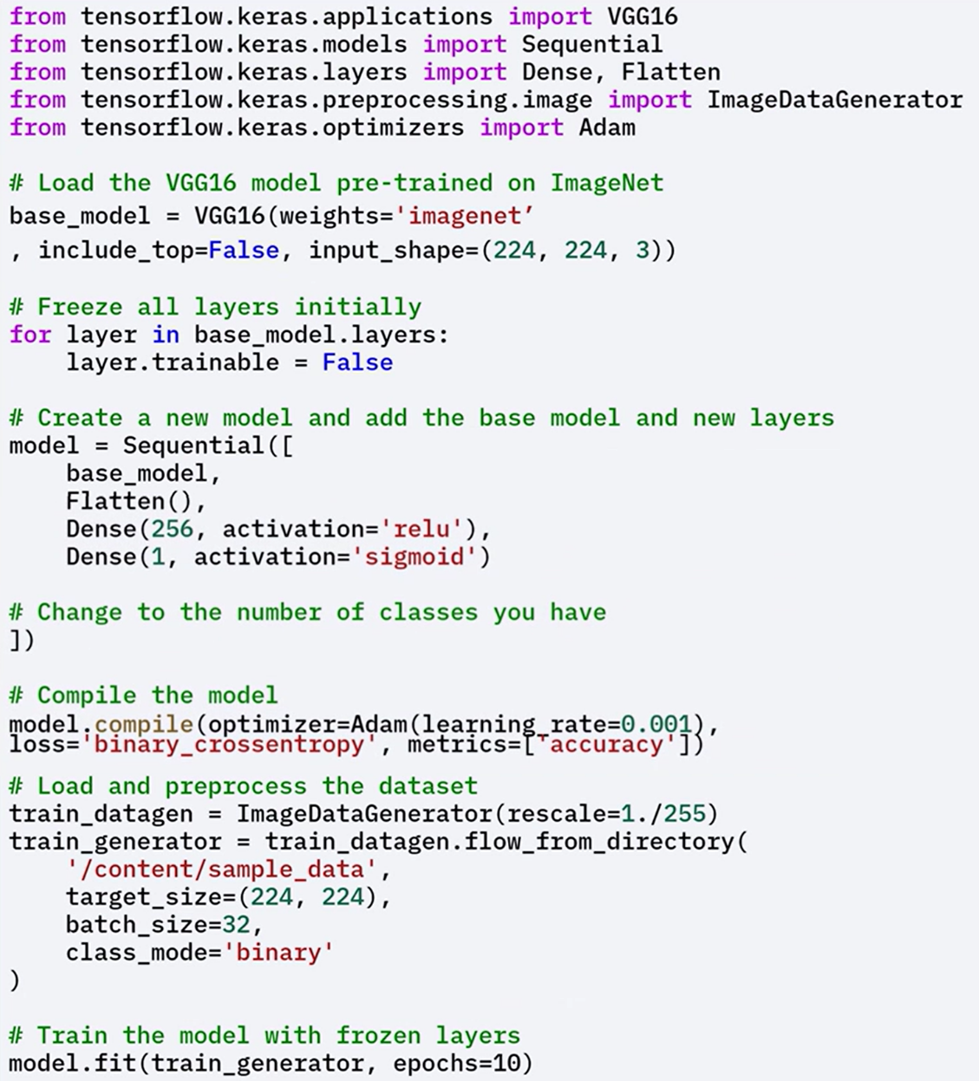

**🛠 Implementation Workflow:**

* Load a pre-trained model (e.g., VGG16) with **include_top=False**.
* Freeze the base layers by setting **layer.trainable = False**.
* Add custom layers for the new classification task.
* Compile the model with an appropriate optimizer and loss.
* Load the dataset using **ImageDataGenerator** with rescaling.
* Train only the newly added top layers.

### 🔹 Fine-Tuning Pre-trained Models

While using a pre-trained model as a fixed feature extractor is effective, **fine-tuning** allows for additional performance improvements by:

* **Unfreezing part of the convolutional base**, typically the upper layers.
* **Jointly training** the newly added dense layers along with the unfrozen base layers.

This process updates weights in the upper convolutional layers to better **adapt the learned representations** to the new dataset.

**⚡When to use Fine-Tuning:**

Fine-tuning is especially useful when:

* The **new dataset differs** significantly from the dataset used to train the original model.
* There's **enough data to support partial retraining**, but not enough for full model training.
* You want to **preserve general features** from the base model while adapting to task-specific details.

**⚡Advantages of Fine-Tuning:**

* **Better alignment with new data**  
  Fine-tuning lets the model learn more nuanced features relevant to the new dataset.
* **Improved performance**  
  Especially when the new task is **similar but not identical** to the original.
* **Efficient transfer learning**  
  Instead of training a deep network from scratch, you build on **already-learned knowledge**.
* **Supports low-data scenarios**  
  Fine-tuning enables strong results even when **full supervised training isn’t feasible**.

#### 🧠 Example of Pre-trained model used as Feature Extractor

ℹ️ **NOTE**: When applying fine-tuning its always better **to initially train the Neural Network with all pre-trained model layers freeze**, so we have a base model to compare with.

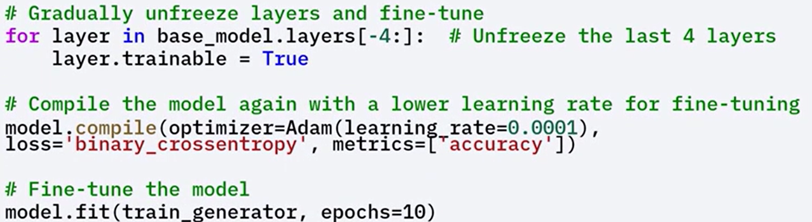

**🛠 Implementation Workflow:**

* **Use a pre-trained model** with the top layers removed.
* **Freeze** all layers initially to train only the new classifier layers.
* **Unfreeze a subset of the top layers** in the base model (e.g., last 4 layers).
* **Recompile the model** to include the updated trainable configuration.
* **Train again**, this time jointly updating the unfrozen base layers and the classifier.

### ✅ Takeaways

✅ Pre-trained models can be used as fixed feature extractors for tasks like classification, clustering, and visualization.

✅ Feature extraction requires no additional training and works well with limited data and compute.

✅ Fine-tuning selectively updates upper layers of the pre-trained model to better adapt to new datasets.

✅ Transfer learning enables high performance even when the new dataset differs from the original training data.

✅ Using pre-trained models accelerates development, improves accuracy, and reduces the need for large labeled datasets.

## 📌 Image Processing with TensorFlow

TensorFlow offers a powerful suite of tools and APIs for performing **image processing tasks**, from basic transformations to model-ready pipelines. These capabilities are essential for building scalable and efficient computer vision applications.

**📘 What Is Image Processing?**

Image processing refers to the practice of **transforming or analyzing images** to extract useful information or to prepare data for model training. It is a foundational step in computer vision pipelines.

Image processing is used across a wide range of fields, including:

* **Medical Imaging** – Analyzing scans for diagnostics (e.g., X-rays, MRIs)
* **Autonomous Vehicles** – Object detection and environment mapping
* **Facial Recognition** – Identifying or verifying individuals from images
* **Robotic Vision** – Interpreting environments for interaction

**⚙️ Why Use TensorFlow for Image Processing?**

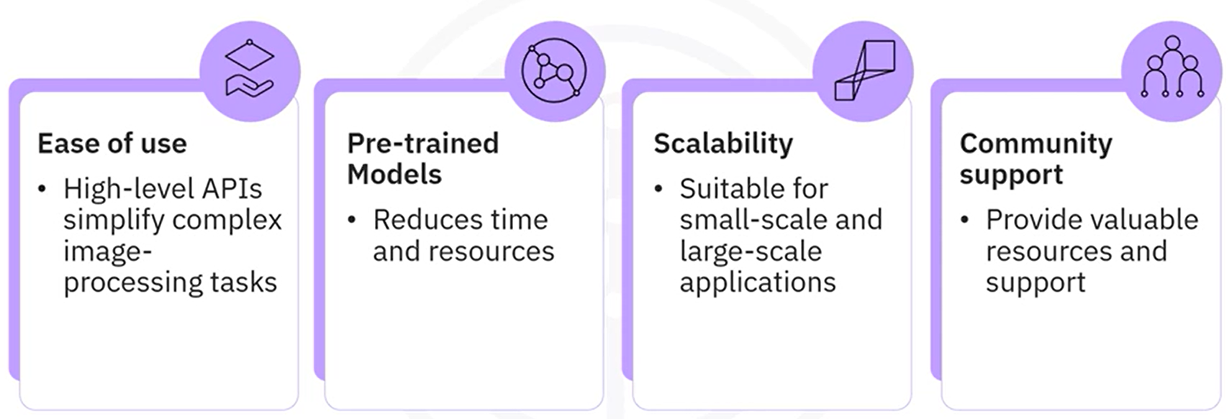

### 🔹 Basic Image Processing Tasks in TensorFlow

The process for preparing images with TensorFlow includes a series of preprocessing steps. These steps are crucial for ensuring that the input data is in the correct format for inference or training.

**1. Image Loading and Resizing**

* Load an image from disk
* Resize the image to the dimensions expected by the model (e.g., 224 × 224 pixels)

**2. Convert to Array**

* Convert the image into a NumPy array, which is the format TensorFlow models operate on.

**3. Add Batch Dimension**

* Models expect input with a batch dimension, which is necessary for model predictions.
* Expand the image shape to match: [batch_size, height, width, channels].

This is required even when working with a **single image**, as TensorFlow models are batch-oriented.

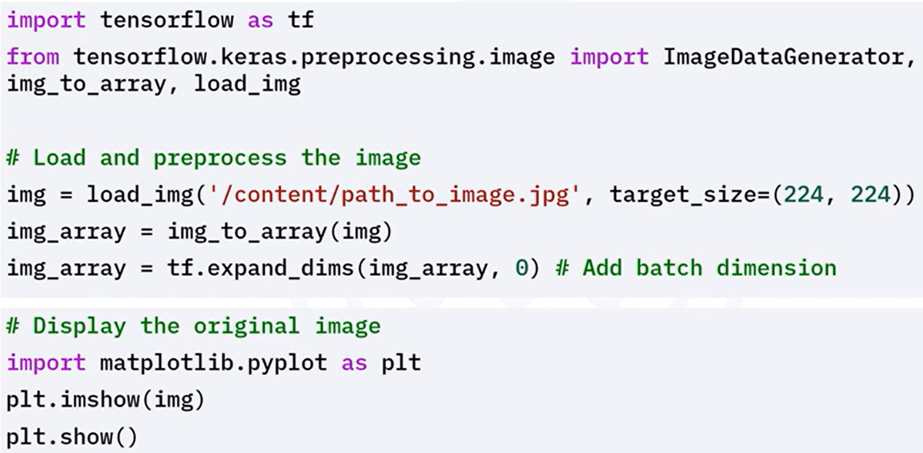

### 🔹 Image Augmentation in TensorFlow

**Data augmentation** is the process of applying random transformations to training images in order to improve a model’s generalization and robustness.

These transformations simulate variations in the training data and help prevent overfitting.

**✨ Common Augmentations Include:**

* **Rotation** – Randomly rotate the image
* **Translation (Shift)** – Move image left, right, up, or down
* **Shear** – Apply shearing transformation
* **Zoom** – Randomly zoom in/out
* **Horizontal Flip** – Flip image horizontally

**📦 Workflow:**

* Configure augmentation parameters
* Use data generators to apply augmentations during training
* Augmented images are produced in batches to feed into models

This setup ensures the model sees a **diverse range of image variants** across epochs, enhancing its ability to generalize.

### ✅ Takeaways

✅ TensorFlow provides robust tools for **loading, preprocessing, and augmenting images**.

✅ It supports both **basic transformations** (e.g., resizing, batching) and **advanced augmentations** (e.g., rotation, zoom, flip).

✅ These capabilities make it easier to train robust models with better generalization on unseen data.

✅ TensorFlow’s ecosystem provides **scalability**, **pre-trained models**, and **developer support**, making it ideal for modern image processing workflows.

## 📌 Tips for Transfer Learning Implementation

Transfer learning is a powerful technique that enables the use of pre-trained models on new tasks, significantly saving time and computational resources. Here are key tips for implementing transfer learning effectively:

1. **Choose the right pre-trained model:** Select a model trained on a dataset similar to your target task to enhance performance. Popular models like VGG16, ResNet, or InceptionV3 are particularly effective for image-related tasks. Ensure that the architecture aligns with your specific problem requirements.
2. **Freeze early layers:** In the initial training stages, freeze the early layers of the pre-trained model to preserve their learned features. This approach is beneficial when working with small datasets or datasets that closely resemble the original dataset the model was trained on.
3. **Fine-tune later layers:** As training progresses, gradually unfreeze the deeper layers and fine-tune them. These layers capture task-specific features, and fine-tuning allows the model to adapt better to the nuances of your new dataset.
4. **Adjust learning rates:** Use a lower learning rate for fine-tuning to prevent catastrophic forgetting of the pre-trained knowledge. High learning rates during this phase can disrupt the learned features and degrade model performance.
5. **Use data augmentation:** Implement data augmentation techniques, particularly for image tasks, to increase variability within the dataset. This practice helps prevent overfitting and enhances the model's ability to generalize.
6. **Consider domain adaptation:** If there is a significant disparity between the domain of the pre-trained model and your target task, consider applying domain adaptation techniques. These methods can help align the source and target datasets, improving the model's performance.

By following these tips, you can optimize your use of transfer learning, enhancing your model's performance with minimal additional effort.